1. Map of personas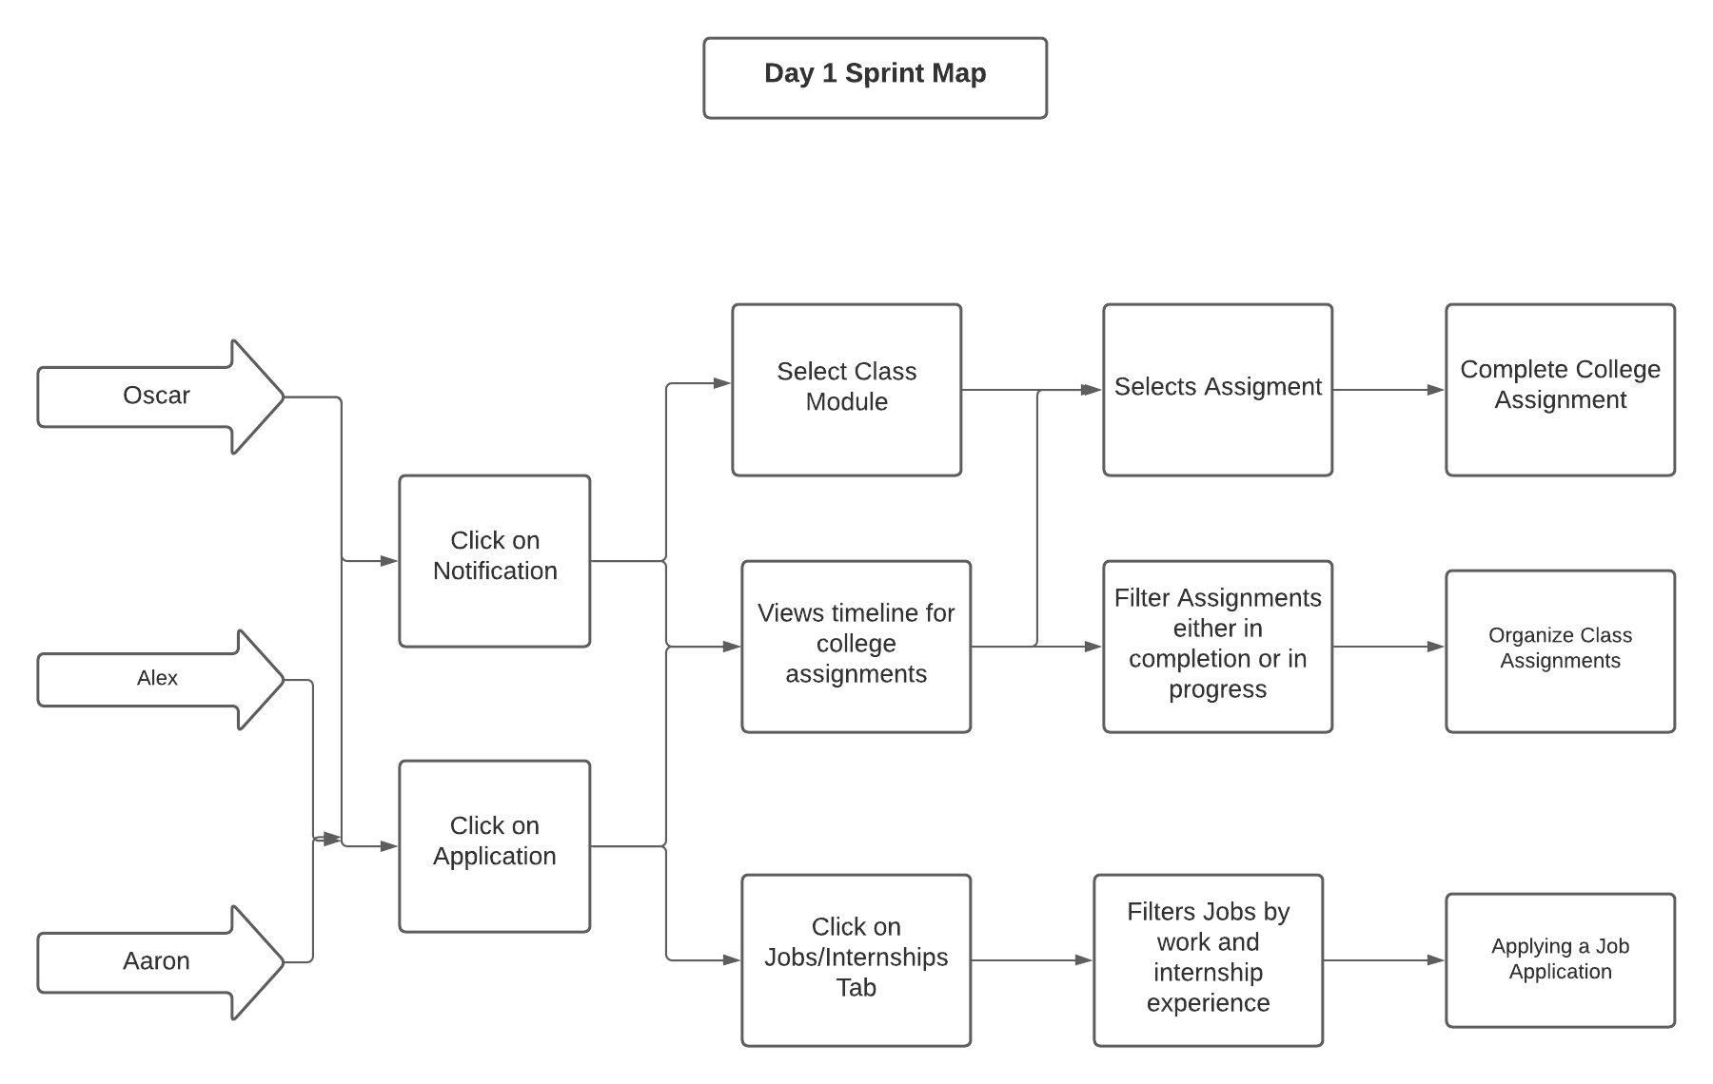
2. Scenarios and users stories:

Oscar Pines is a junior in college and usually has professors that are usually organized with their materials and assignments. However, for Oscar’s current semester, one of his professors’ organization of assignments is somewhat disorganized and hard to follow. Oscar is worried that he isn’t to get his work done through the disorganization. Luckily, the university uses software called “Crystal” which has a feature that showcases a timeline of assignments. Oscar then opens up the software and views a timeline of assignments for all of his current classes. Oscar wants to complete an assignment that is due today, so he clicks on the assignment on today’s date and completes it for the day. Now Oscar has an updated view of his timeline since he finished the assignment.

1. Feature List:
   1. Have a timeline of assignments that a student can view
      1. Able to filter assignments that are complete, in progress, haven’t started yet
   2. Able to give an assignment a complete tag and in progress tag
      1. Assignments will already have a haven’t started tag